Legal Aid Census Suggested Tweets

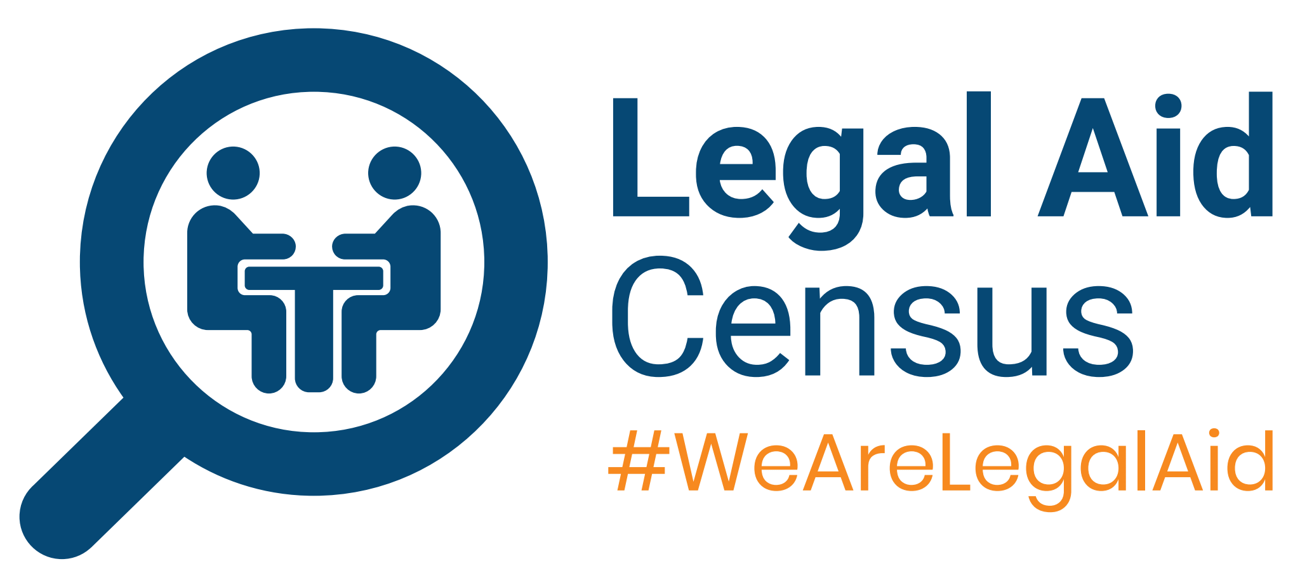

**Variation One**

Calling all current, former and aspiring legal aid practitioners! Stand up and be counted in the #LegalAidCensus, the largest survey of the post-LASPO landscape that will help inform research and policy to shape the sector. Take part here: <https://appg.onlinesurveys.ac.uk/legalaidcensus2021>

#WeAreLegalAid

**Variation Two**

All current, former and aspiring legal aid practitioners, we need YOU to stand up and be counted in the #LegalAidCensus.

The largest survey of the post-LASPO landscape will inform research and policy to shape the sector. Take part here: <https://appg.onlinesurveys.ac.uk/legalaidcensus2021>

#WeAreLegalAid

**Variation Three**

We need YOU to stand up and be counted in the #LegalAidCensus. From aspiring practitioners to legal aid veterans or those who have left, we need your answers to inform research, shape policy and change the sector. Take part here: <https://appg.onlinesurveys.ac.uk/legalaidcensus2021>

#WeAreLegalAid